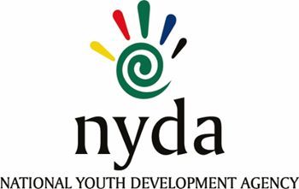

**TENDER AWARD INFORMATION**

|  |  |  |
| --- | --- | --- |
| **TENDER NUMBER** | **DESCRIPTION** | **TENDER AWARDED TO** |
| **RFP2022/04/NYDA** | APPOINTMENT OF THE PANEL OF YOUTH-LED NON-PROFIT ORGANISATIONS TO IMPLEMENT THE NATIONAL YOUTH SERVICE EXPANDED VOLUNTEER PROGRAM OVER A PERIOD OF THREE YEARS **-** | 1. Deprived Youth Service 2. Thupa-Lethu Development Forum 3. Laapeng Foundation Project 4. Young Life Development Organisation 5. Usizo Organisation 6. Woman Who Cares 7. Nurses At Ago 8. Embo Yakwa Ntu NPC 9. Kgorogo Social Investments 10. Khaltsha Spaces 11. Micah Block Foundation 12. Youth Life Organisation 13. Own Pace Foundation NPC 14. Tafelkop Lesedi H.B.C 15. Siphumelele Youth Organisation 16. Mawela Community Development 17. Thuto Ke Mahlo 18. Phumelela Home Base Care 19. Ntsika Ye Sizwesethu 20. South African College For Mathematics, Scienceand Technology 21. Senza Kwenzeke Care Center 22. JumpStart Your Career 23. Lesibanzi Foundation 24. Banobubele Development Project 25. Global Health for Social Change Network NPC 26. NGO Connect SA 27. Mo-Africa Ithlokomele Educational Projects 28. Ikusasalethu Youth Development Project 29. Set Her Up To Win Woman 30. National Institute Community Development And Management Trust T/A NICDAM 31. Thembisa Serenade 32. Kwetso Foundation 33. Ebenezer Helping Hands 34. Tsoga Mosadi 35. We Build You NPO 36. Backyard Farmers |