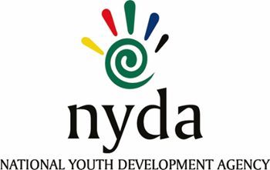

**TENDER AWARD INFORMATION**

|  |  |  |
| --- | --- | --- |
| **TENDER NUMBER** | **DESCRIPTION** | **TENDER AWARDED TO** |
| **RFP2023/20/NYDA** | APPOINTMENT OF A 10 NON-PROFIT ORGANISATIONS SERVICE PROVIDERS TO MANAGE THE NATIONAL YOUTH SERVICE PHASE 2 FOR A PROGRAMME OF THE PRESINDENTIAL YOUTH EMPLOYMENT INTERVENTION FOR THE PERIOD OF 12 MONTHS AND A POSSIBLE EXTENSION OF 2 PERIOD OF 12 MONTHS EACH. | 1. YOUTHLIFE  2. KWETSO FOUNDATION  3. Lulwazi Lwethu  4.Spotlite Education Foundation jv  Working Solutions International  5. Seriti Institute  6. Charisma Music Foundation  7. Community Chest Western Cape  8. Crecket South Africa  9. Sport for Social Change Network  10. Southern African Association YouthClubs |