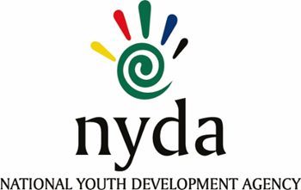

**TENDER AWARD INFORMATION**

|  |  |  |
| --- | --- | --- |
| **TENDER NUMBER** | **DESCRIPTION** | **TENDER AWARDED TO** |
| **RFP2024/3/NYDA** | **APPOINTMENT OF TWO TRAVEL MANAGEMENT COMPANIES FOR THE PROVISION OF TRAVEL AND ACCOMMODATION MANAGEMENT SERVICES TO THE NATIONAL YOUTH DEVELOPMENT AGENCY FOR A PERIOD OF THREE (3) YEARS** | **1. Gemini Moon Trading 7 (Pty) Ltd t/a XL Nexus Travel**  **2. Wings Naledi Travel** |