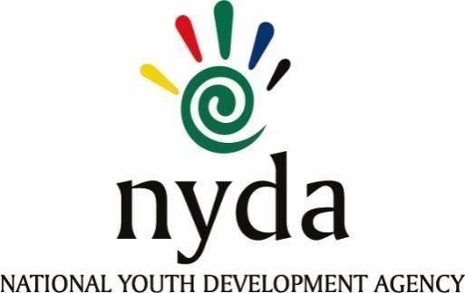

|  |  |  |
| --- | --- | --- |
| **Tender number** | **Tender Description** | **Awarded to:** |
| RFP2023/17/NYDA | Safety file voucher programme | Kasolwazi |
| RFP2023/17/NYDA | Safety file voucher programme | Kele Thabo Holdings |
| RFP2023/17/NYDA | Safety file voucher programme | Huku Holding (Pty) Ltd |
| RFP2023/17/NYDA | Safety file voucher programme | The Business Associate t/a Joseph  Ruiters Investments |
| RFP2023/17/NYDA | Safety file voucher programme | Riva Group (Pty) Ltd |
| RFP2023/17/NYDA | Safety file voucher programme | Rigid link |
| RFP2023/17/NYDA | Safety file voucher programme | Safetyscope (Pty) Ltd |
| RFP2023/17/NYDA | Safety file voucher programme | Itu Solutions |
| RFP2023/17/NYDA | Safety file voucher programme | Thulisile Financial Services |
| RFP2023/17/NYDA | Safety file voucher programme | Molemi Management Systems  Consulting |
| RFP2023/17/NYDA | Safety file voucher programme | Real Time Development |
| RFP2023/17/NYDA | Safety file voucher programme | Assagy Environmental (Pty) Ltd |
| RFP2023/17/NYDA | Safety file voucher programme | Ilitha Management Consultants |
| RFP2023/17/NYDA | Safety file voucher programme | NGI Holdings (Pty) Ltd |
| RFP2023/17/NYDA | Safety file voucher programme | Luthando – Nto General Trading  Enterprise |
| RFP2023/17/NYDA | Safety file voucher programme | TMKT Holdings |
| RFP2023/17/NYDA | Safety file voucher programme | BM Holdings |
| RFP2023/17/NYDA | Safety file voucher programme | Sorcabriz Investments (Pty) Ltd |
| RFP2023/17/NYDA | Safety file voucher programme | ThakgProductions cc |
| RFP2023/17/NYDA | Safety file voucher programme | Delta Built Environment  Consultants |
| RFP2023/17/NYDA | Safety file voucher programme | Ocean Innovations (Pty) Ltd |
| RFP2023/17/NYDA | Safety file voucher programme | Molesiwa Consulting |
| RFP2023/17/NYDA | Safety file voucher programme | Victorious Group Inc |
| RFP2023/17/NYDA | Safety file voucher programme | Smart code Institute |
| RFP2023/17/NYDA | Safety file voucher programme | Vuwa Holding (Pty) Ltd |
| RFP2023/17/NYDA | Safety file voucher programme | Khoali Group (Pty) Ltd |
| RFP2023/17/NYDA | Safety file voucher programme | Vaal Group of companies |
| RFP2023/17/NYDA | Safety file voucher programme | Lemock Group (Pty) Ltd |
| RFP2023/17/NYDA | Safety file voucher programme | Real Development t/a Grass roots consulting |
| RFP2023/17/NYDA | Safety file voucher programme | Gatsheni Sizwe |
| RFP2023/17/NYDA | Safety file voucher programme | SNS Smart Tech |
| RFP2023/17/NYDA | Safety file voucher programme | Mapiyo Enterprise |
| RFP2023/17/NYDA | Safety file voucher programme | Xwi Trading and Projects |
| RFP2023/17/NYDA | Safety file voucher programme | Mink-line Consulting |
| RFP2023/17/NYDA | Safety file voucher programme | Tanosa Group |
| RFP2023/17/NYDA | Safety file voucher programme | Digi Natives |
| RFP2023/17/NYDA | Safety file voucher programme | Tshilisanani Communications |